Kiptoo Ezra kimosop
Bsccs/2024/43935
Computer Science
BIT
Ethical Hacking and Counter measures
Nyoro Michael
Year 4

Contents
Week 1: Local Environment Setup 3
Installation and Testing of Local Development Environment 3
Week 2:Information Gathering 5
Collection of data 5
Week 3: Scanning and Enumeration 9
Scanning 9
Week 4: Gaining access 11
Controlled exploitation 12

Executive Summary
Target Domain: owasp.org
Assessment Date: June 4, 2026

Week 1: Local Environment Setup
Title

Installation and Testing of Local Development Environment
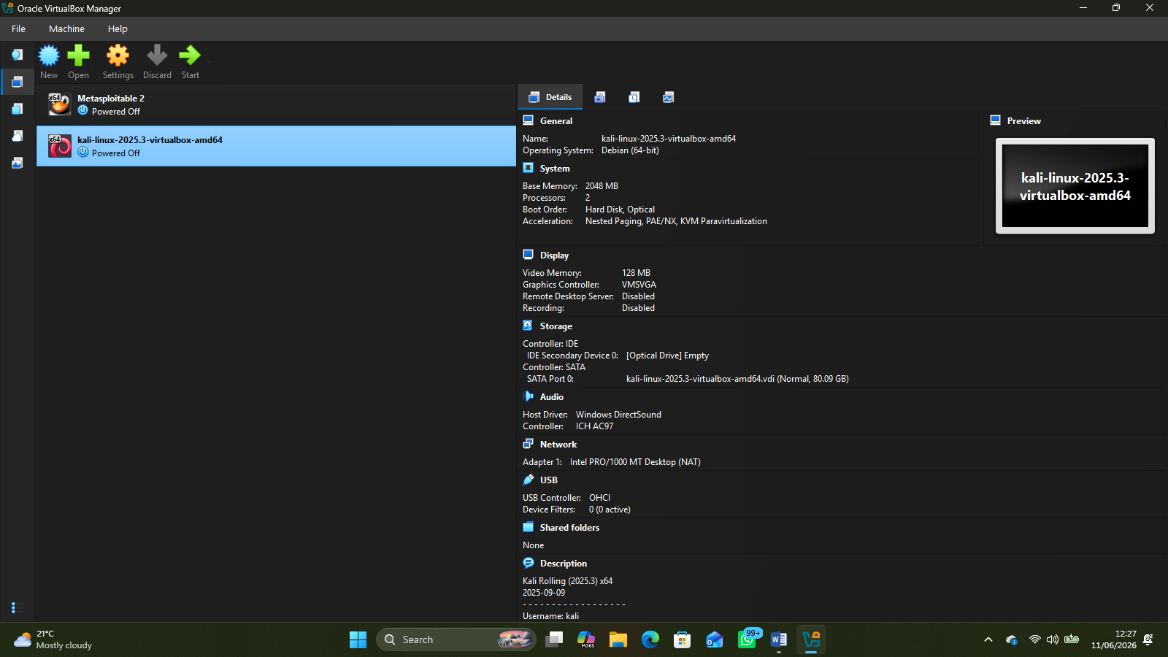
(Installing of kali machine)

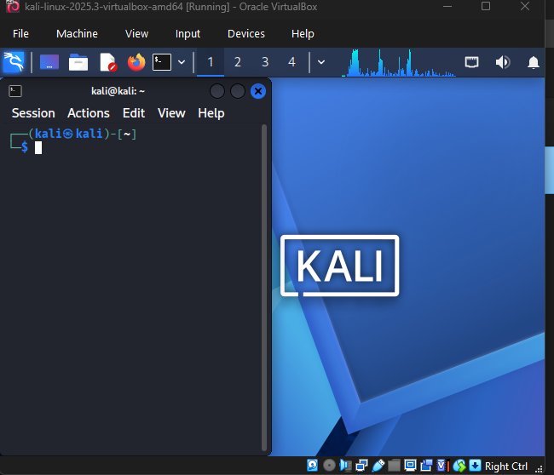
(kali in virtual machine with terminal)
Student Reflection
I learned how to install and configure Kali Linux on VirtualBox, create and manage virtual machines, and troubleshoot common installation and boot issues.
Technologies Used:
The technologies used included VirtualBox, Kali Linux ISO image, Windows 11, and virtualization technology.
Challenges Encountered:
Some challenges included configuring the virtual machine settings, allocating sufficient system resources, attaching the correct ISO file, and resolving startup errors such as missing or inaccessible virtual disk files.
What the Screenshots Demonstrate:
Demonstrate VirtualBox configuration settings, successful booting of Kali Linux, and the completed virtual machine environment ready for use.

Week 2:Information Gathering
Title

Collection of data
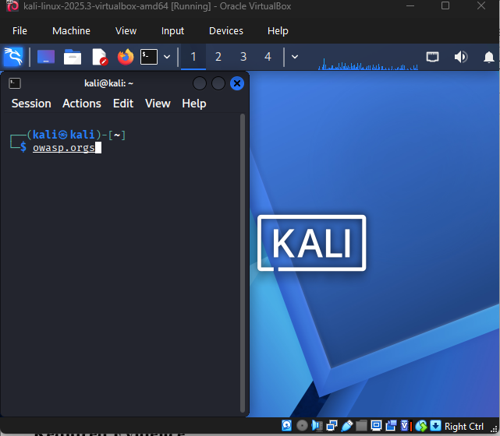

(sample org to gather information from)
Subdomain

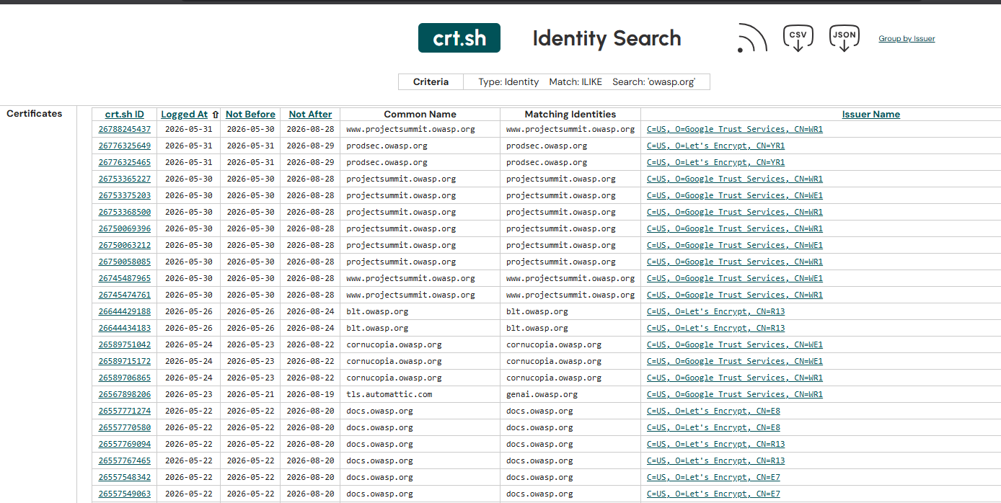
(subdomain using crt.h)

Email pattern
LinkDR
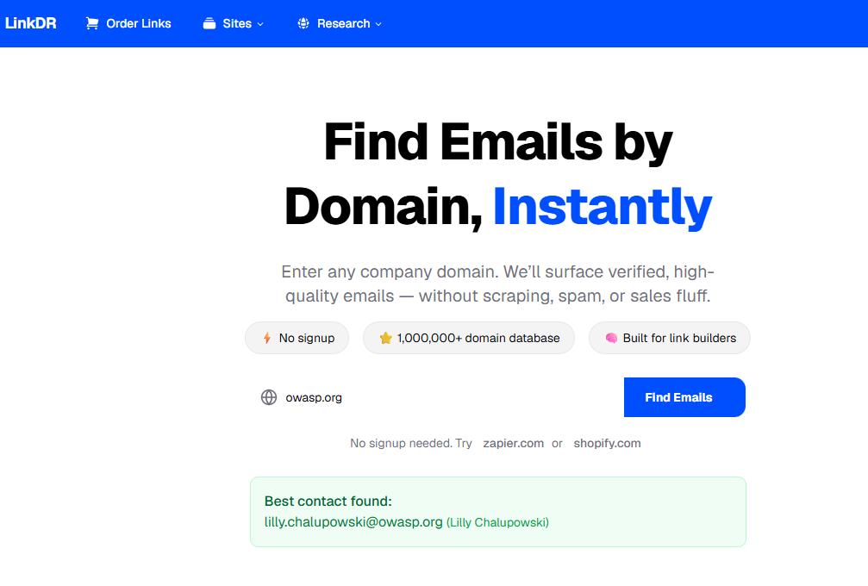
Technology stack
wappalyzer
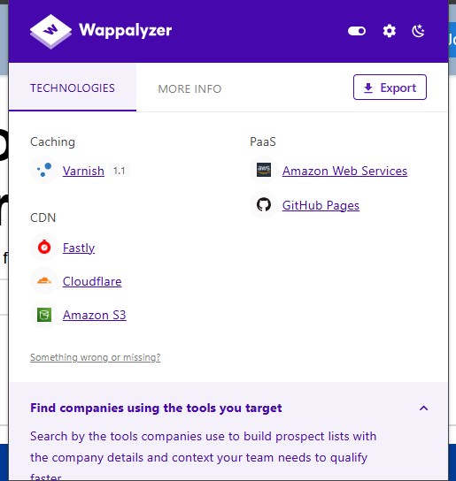

(Technology stack)

Registrer and hosting
Whois

(
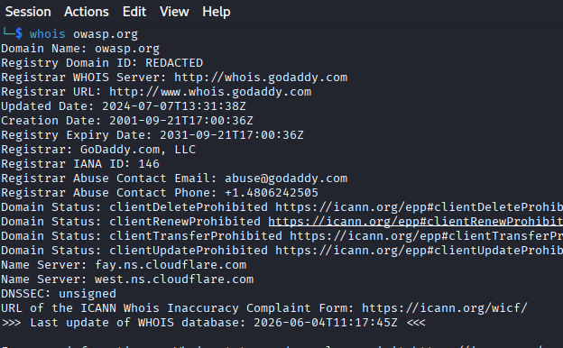
(Domain Register)

Student Reflection
Why the Design Was Selected: The design combines domain analysis, email pattern discovery, credential exposure checks, and technology identification in one platform.
User Experience Considerations: A simple interface allows users to enter a company name or domain and view results clearly.
How Navigation Flow Was Planned: Users enter a target, start a scan, and view findings organized into sections.
Intended System Users: Cybersecurity students, security researchers, penetration testers, and IT professionals conducting security assessments and reconnaissance.

Week 3: Scanning and Enumeration
Title

Scanning

Exposed services
Nmap
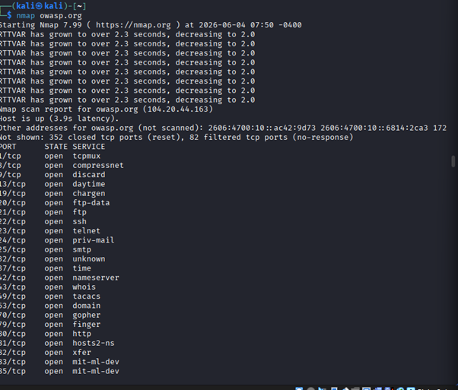
(identify open ports using nmap)
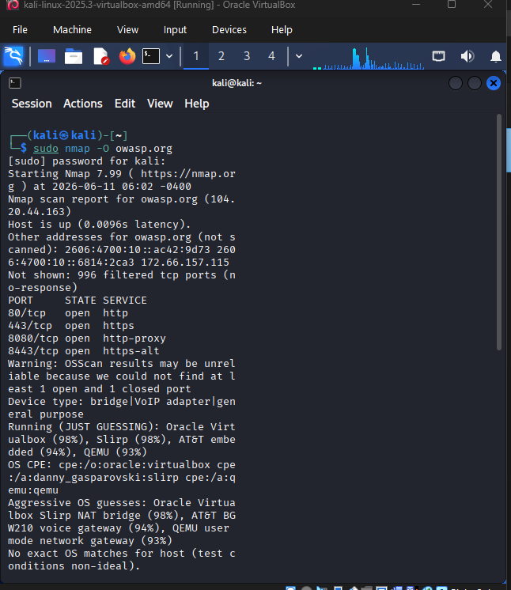
(identifying OS version)

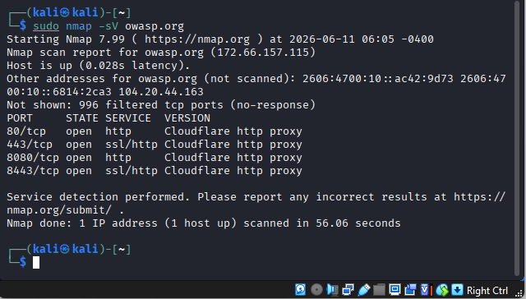
(Running Services)

Student Reflection
Skills and Knowledge Gained
I gained practical experience in network reconnaissance and security assessment. I learned how to scan ports, detect running services, identify operating system versions, and gather information about target systems using Nmap.
Challenges Encountered
One challenge was interpreting scan results accurately and understanding the information returned by different Nmap scan options. Troubleshooting connectivity and configuration issues also required careful analysis.
Reflection
This project improved my understanding of network security and system enumeration. The hands-on experience strengthened my technical skills and demonstrated the importance of information gathering in cybersecurity assessments.

Week 4: Gaining access
Title

Controlled exploitation

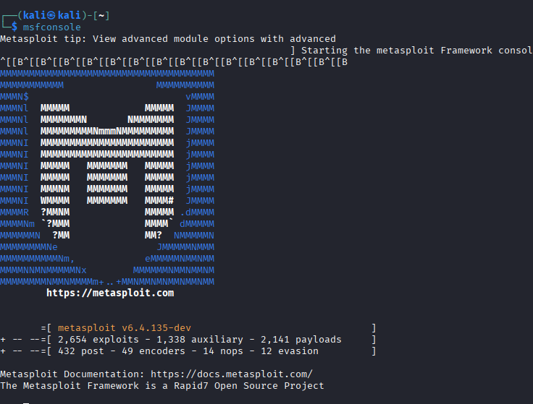
(use metasploit)

(choose your weapon)
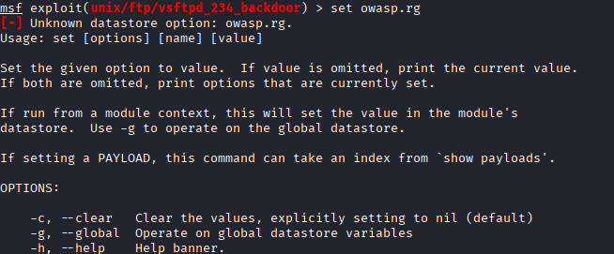
(set target)
(Run)

Student Reflection
Skills and Knowledge Gained
I learned how to identify vulnerabilities, exploit weaknesses using Metasploit, scan ports, detect running services, and identify operating system versions. I also gained a better understanding of penetration testing and system security assessment.
Challenges Encountered
One challenge was understanding the different exploitation modules and selecting the appropriate exploits for identified vulnerabilities. Troubleshooting failed exploits and interpreting scan results also required careful analysis.
Student Reflection
This project provided valuable hands-on experience in cybersecurity. It helped me understand how vulnerabilities can be exploited and reinforced the importance of securing systems against attacks. The practical exercises improved my technical skills and confidence in using security tools.

